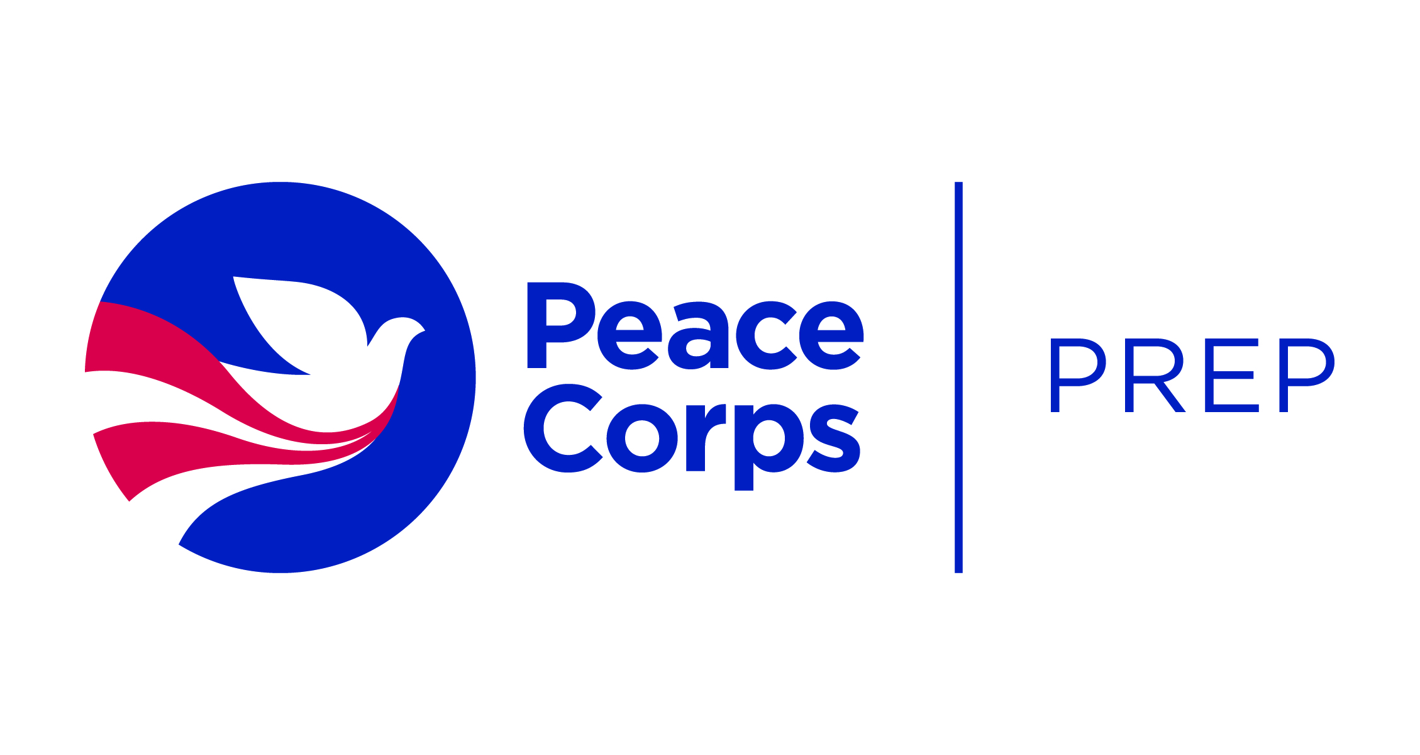

Name: _________________________________
Date: __________________________________

Planning Form

Below are the Peace Corps Prep certification requirements. Use this document to start your plan for meeting the program requirements. Refer to the current Student Guide for relevant courses, resources, and ideas. We will work with you to finalize your plan! Remain FLEXIBLE: listing a class on your planning form does NOT guarantee you a space in that class.

- Training and experience in a specific work sector
Please check or HIGHLIGHT the sector in which you would like to serve or specialize:

- Education
- Health
- Environment
- Agriculture
- Youth in Development
- Community Economic Development

- Coursework. Refer to the Student Guide to see the range of majors/minors that relate to these six sectors! List the 3 highest sector-aligned course #s and titles you plan to take (9 credit hours):

- _____________________________
- _____________________________
3. ________________________________

- Hands-on experience in that SAME SECTOR, ideally in a teaching or outreach capacity. Total hours must be at least 50. What future or prior activities might be relevant?

- Foreign language skills (strongly encouraged, but not required)
Requirements depend upon desired Peace Corps volunteer placement site. (1) Spanish-speaking countries two 200-level courses. (2) French-speaking countries one 200-level course in any Romance Language. (3) Everywhere else no explicit requirements, but language skills are a plus. If you meet this requirement, you may be well positioned to add a language minor.
Language: ____________________ List your 2 highest level course #s and titles:

1. __________________________
2. __________________________

Or describe your alternative learning process (e.g., native speaker):

- Intercultural competence
List your 3 approved courses that bolster your intercultural competence (9 credit hours)—many courses overlap with General Education requirements:

- _____________________________
- _____________________________
3. ________________________________

- Professional and leadership development
- Career Center resume feedback: Pending, OR Completed, Date: ________

- Career Center interview prep: Pending, OR Completed, Date: ________

- Demonstrated leadership experiences (i.e., student organizations, work, volunteer, etc.). What future or prior activities might be relevant?

