How to input your internship record into Hire-A-Redbird:
- Log in to Hire-A-Redbird by going to this link: https://careerservices.illinoisstate.edu/hire-a-redbird/ and clicking the red button that says “Sign In to Your Student Account.”
From there, you can login using your ULID and password.
- Your home page should look something like this:
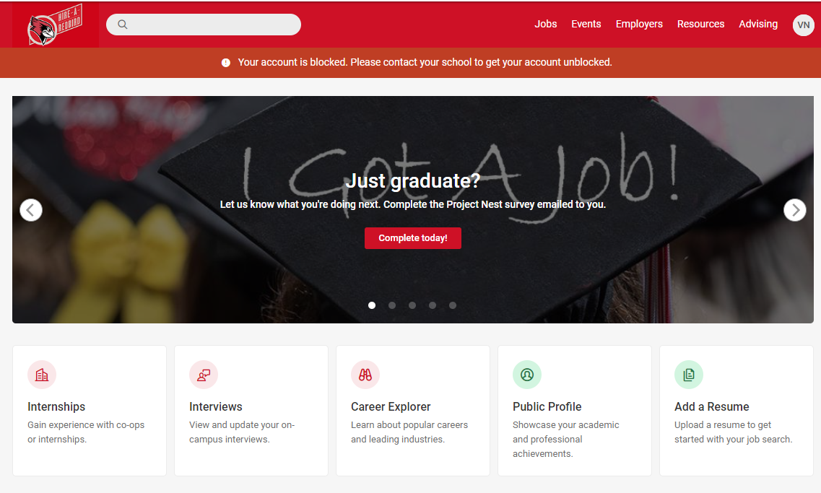
- You will now click on the “Internships” button (located in ton the bottom left, next to the “Interviews” button). This will open a new screen—click “Add New Experience.”

- Complete the form
  - For Employer: List your actual internship employer; you may have to create a new one if your site is new
  - For internship job title: write “Stevenson Center Fellow”
  - Add City and State; if remote, write “Remote” into City box and Select “Other” for State
  - For Experiential Learning Type select “For Credit”
  - Make sure you check the box that you’ve read the Acknowledgement Statement
  - For Subject, write you dept abbreviation (ECO, POL, SOC, ANT, KNR)
  - For Catalog Number, write 498
  - For Section, write A90
  - For Credits, please check your plan of study (located on the Stevenson Center website) and add total number of credits. Email the Program Coordinator if you have questions.
  - For Career Direction, Select “Non-Profit, Social Services, Government and Law”
  - Insert your Start and End Date
  - Select Internship as “Paid”
  - For Compensation Type Select Monthly
  - For Compensation amount enter
  - For Hour per week range, select 31-40
  - For supervisor name Please add the Program Coordinator’s name and email, phone number 309-438-5945. DO NOT INSERT YOUR SITE SUPERVISOR’S INFO.
  - For where you found the internship, select Academic Dept/Faculty
  - To list major responsibilities, use your hosts’ application
  - Select the NACE Competencies that fit for you
  - No attachments are required
  - Please Sign
  - Be sure to hit the red “Submit” button

End of semester evaluations:
After putting in your internship record, you will receive an email at the end of your internship semester asking you to complete a survey evaluating your internship experience AND a survey asking you to evaluate yourself during your internship. This is automatically generated by the HARB system. The completion of these surveys is not at all required and total optional as the Stevenson Center collects its own data on internship experiences and learning goal outcomes.

